6.2D – 1 (R) three Y
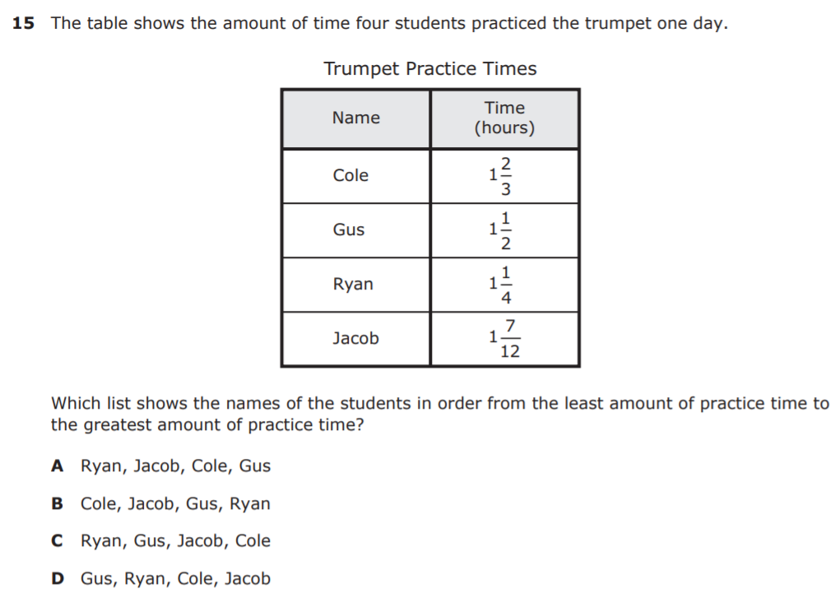
6.2D – 1 (R) four X
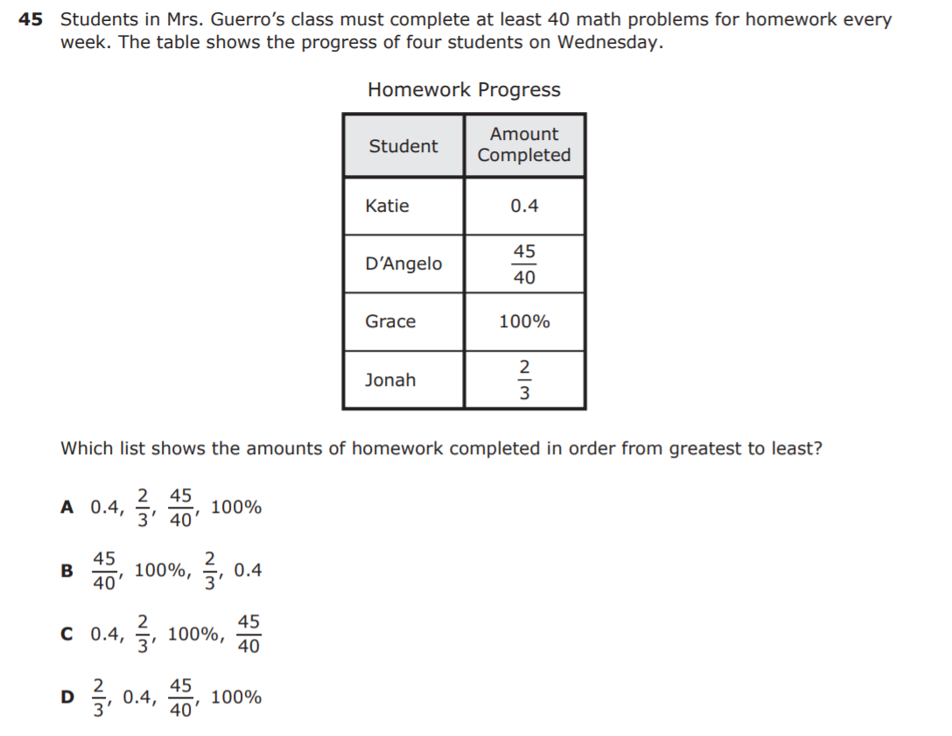
6.2D – 1 (R) two Y
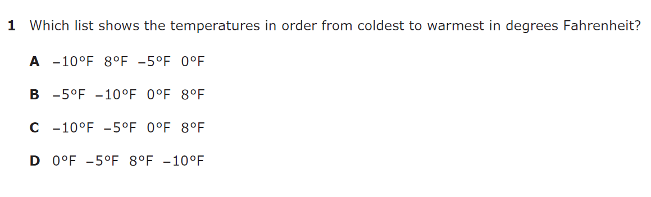

6.2D – 1 (R) three Z 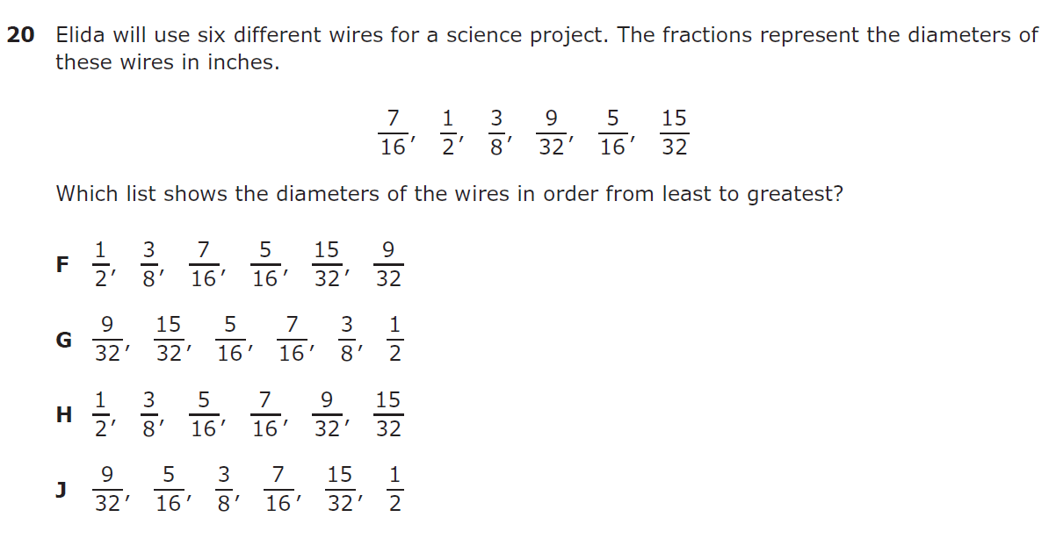

6.2D – 1 (R) four W
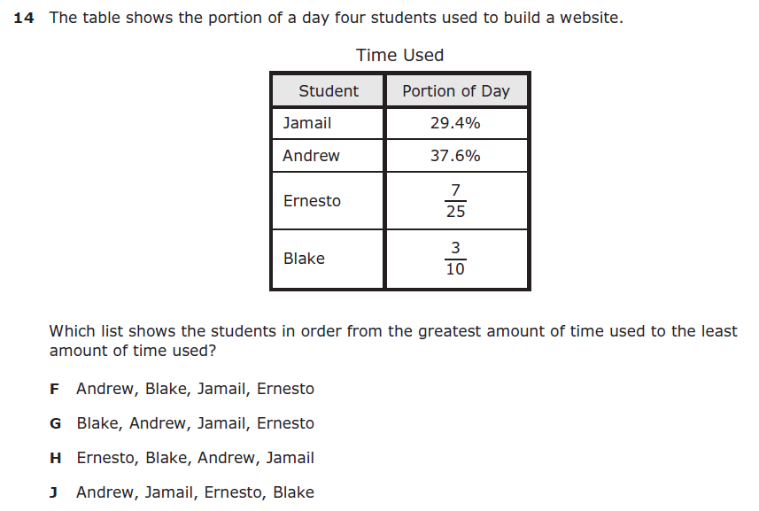
6.2D – 1 (R) five Y
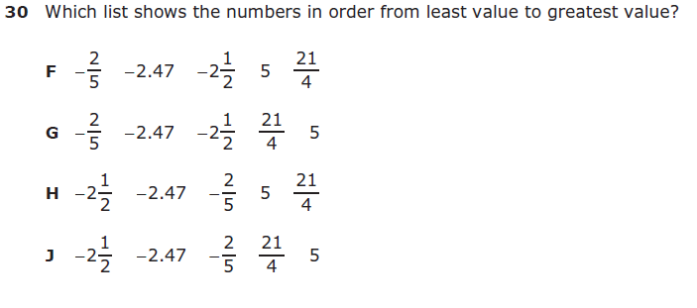

6.3D – 2 (R) six Y
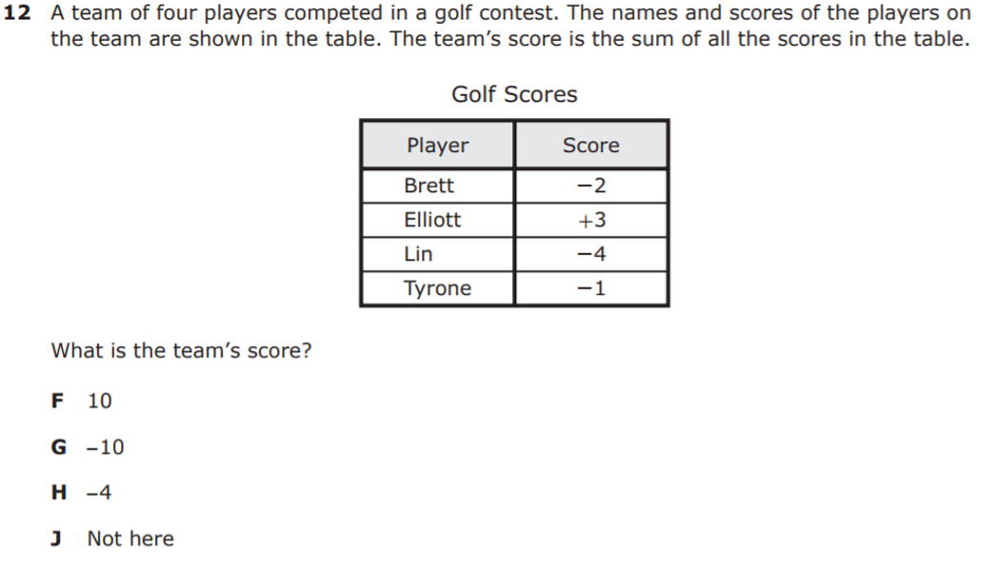

6.3D – 2 (R) seven -14
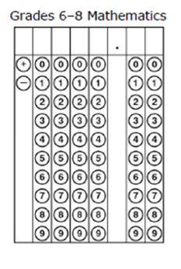
6.3D – 2 (R) six Z 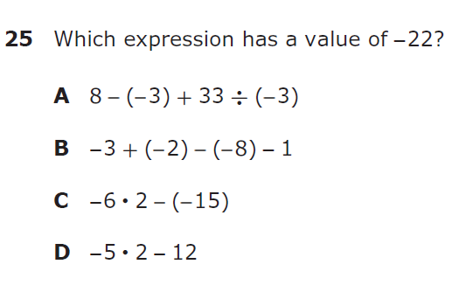

6.3D – 2 (R) seven W
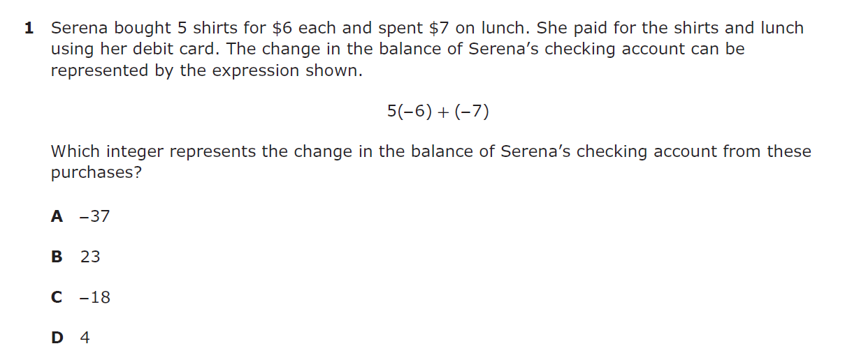

6.3D – 2 (R) eight -14
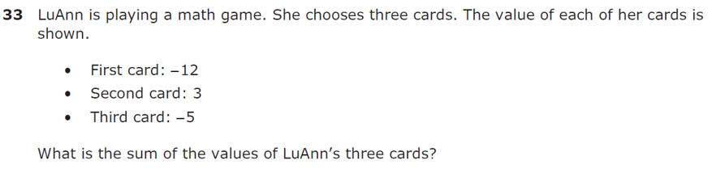
Record your answer and fill in the bubbles on your answer document. Be sure to use correct place value.
6.3E – 2 (R) eight Y
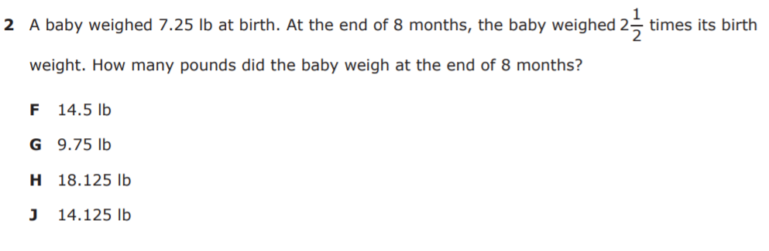

6.3E – 2 (R) nine Z
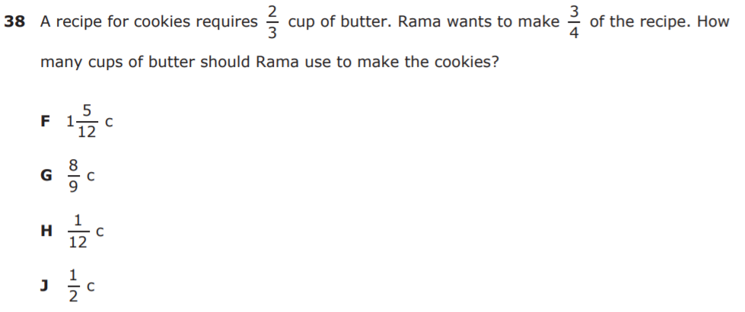

6.3E – 2 (R) seven Z
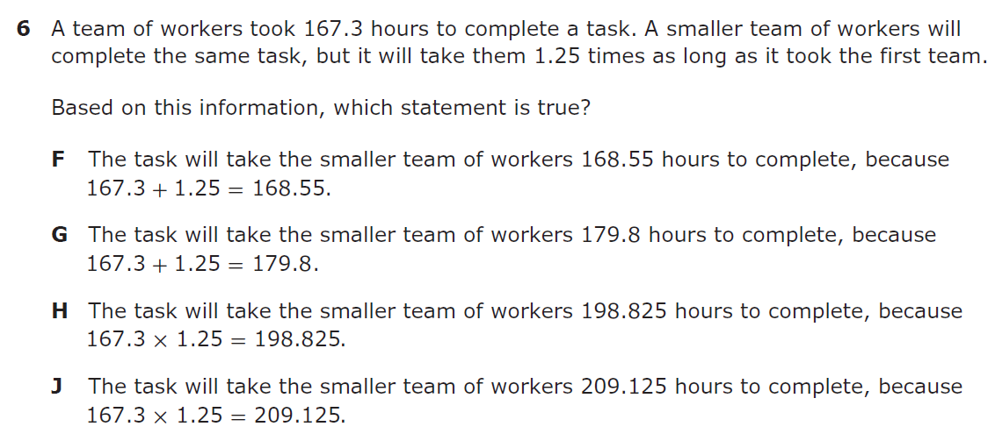

6.3E – 2 (R) seven Z

6.3E – 2 (R) eight Z
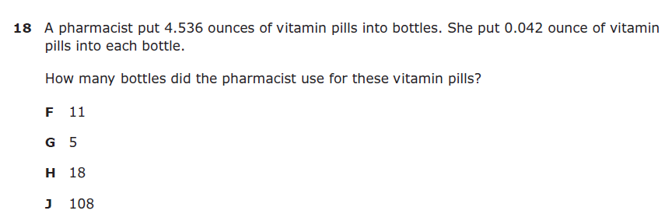

6.4B – 2 (R) eleven Z
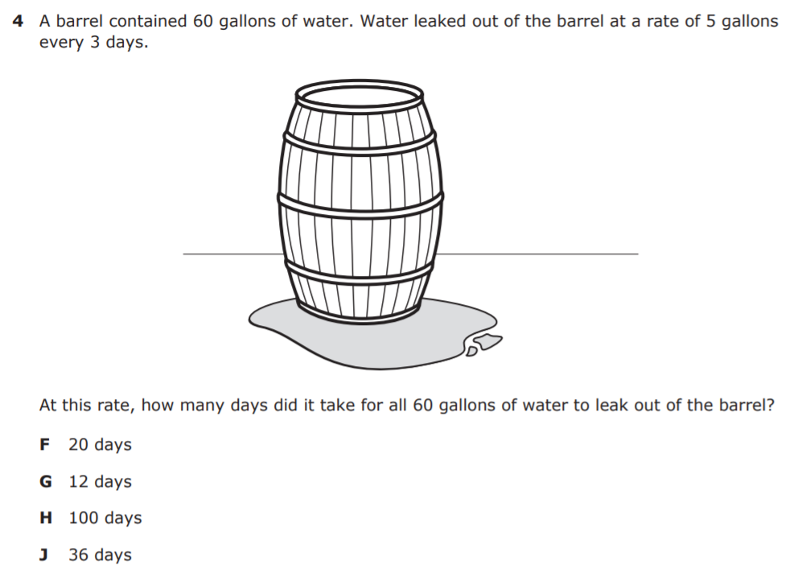
6.4B – 2 (R) twelve W
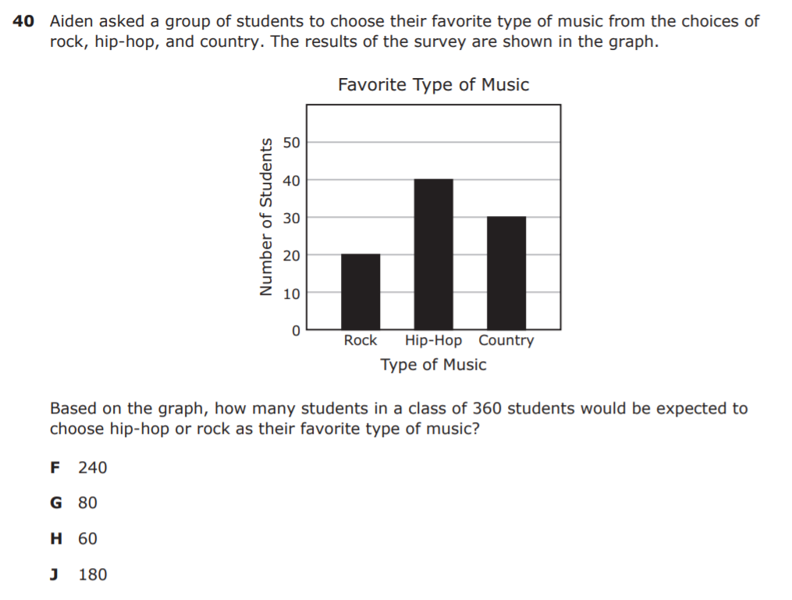
6.4B – 2 (R) Ans: 320 eight
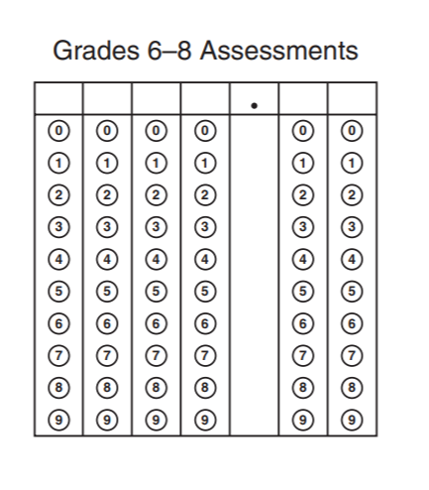

6.4B – 2 (R) nine W
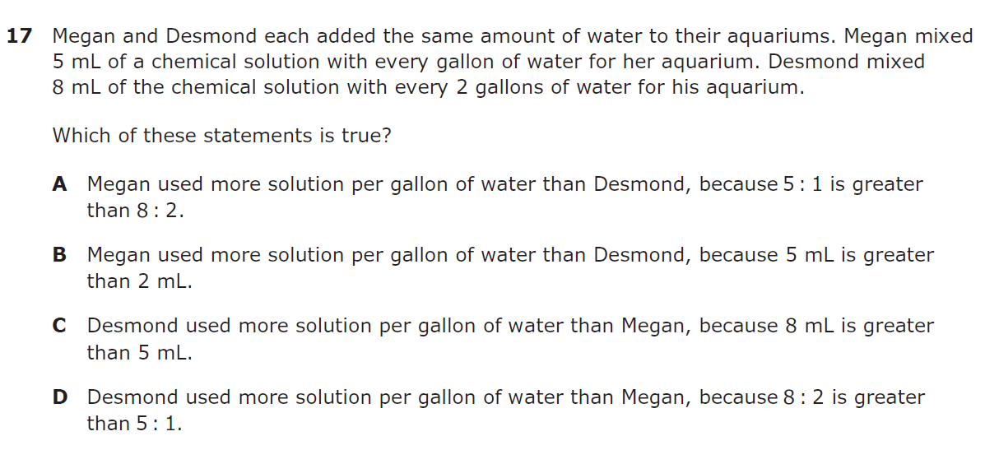

6.4B – 2 (R) ten W
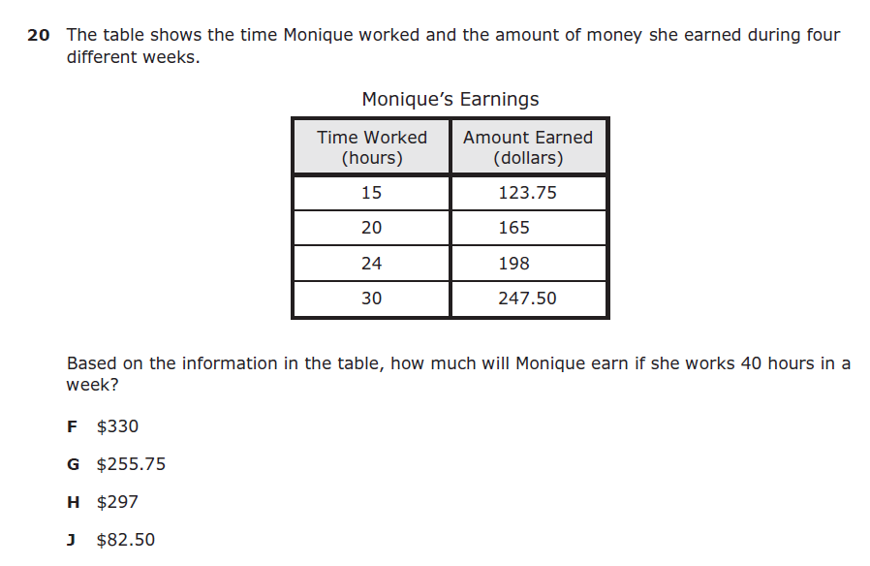

6.4G – 1 (R) sixteen X
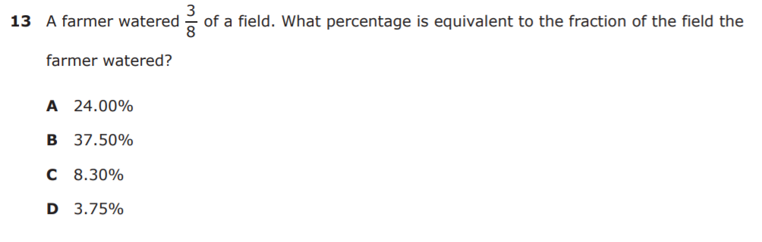

6.4G – 1 (R) seventeen X
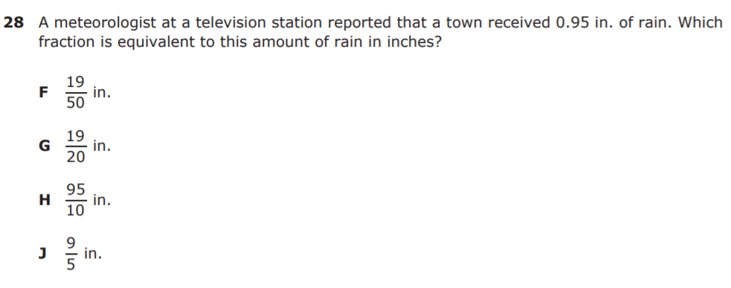

6.4G – 1 (R) Ans: 0.8 eighteen
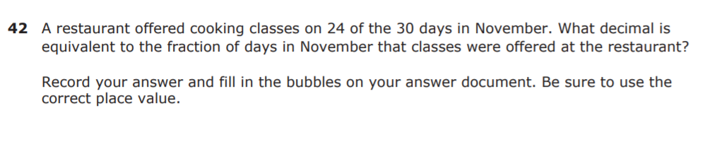

6.4G – 1 (R) eleven Y
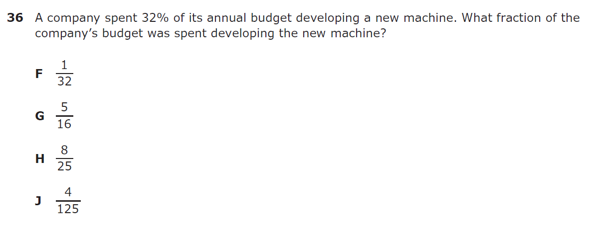

6.4G – 1 (R) twelve 0.17

6.4G – 1 (R) twelve Z
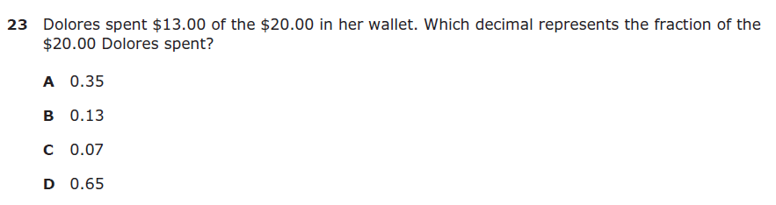

6.4H – 3 (R) nineteen X
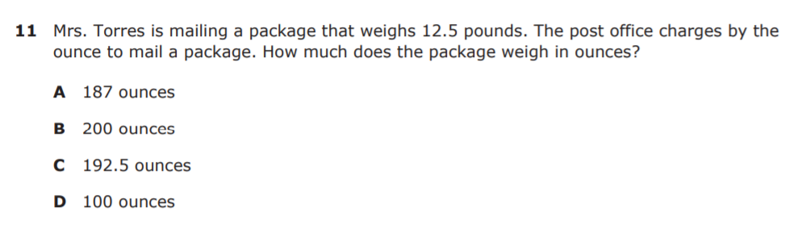

6.4H – 3 (R) twenty W
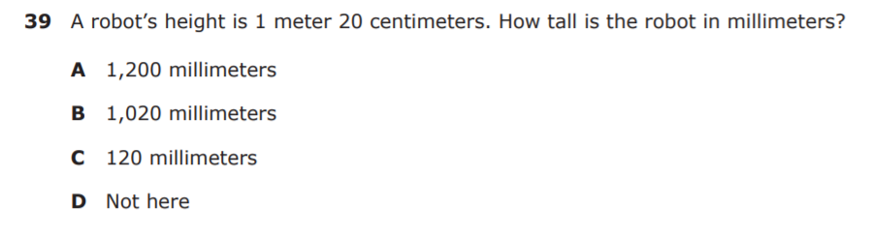

6.4H – 3 (R) twelve W
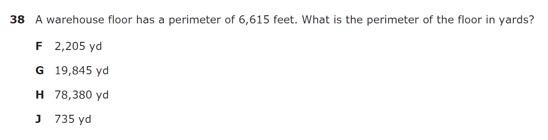

6.4H – 3 (R) thirteen Y
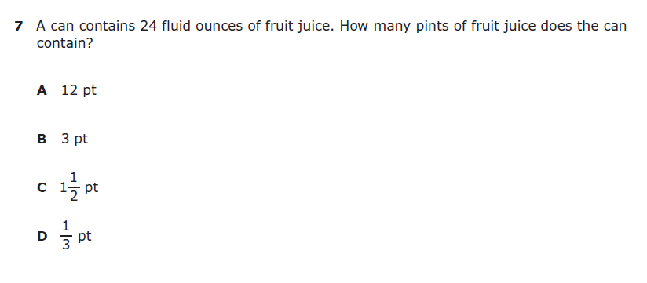

6.5B – 2 (R) twenty two W
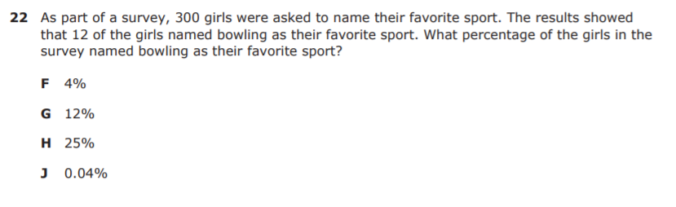

6.5B – 2 (R) twenty three Y
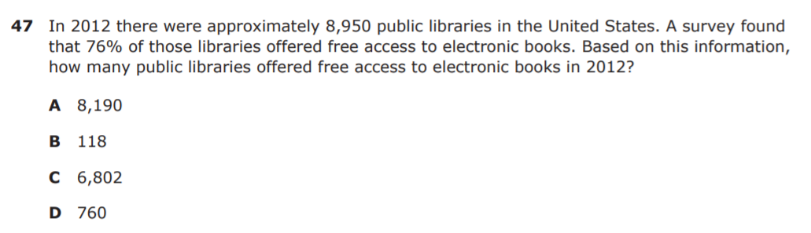

6.5B – 2 (R) fourteen Z
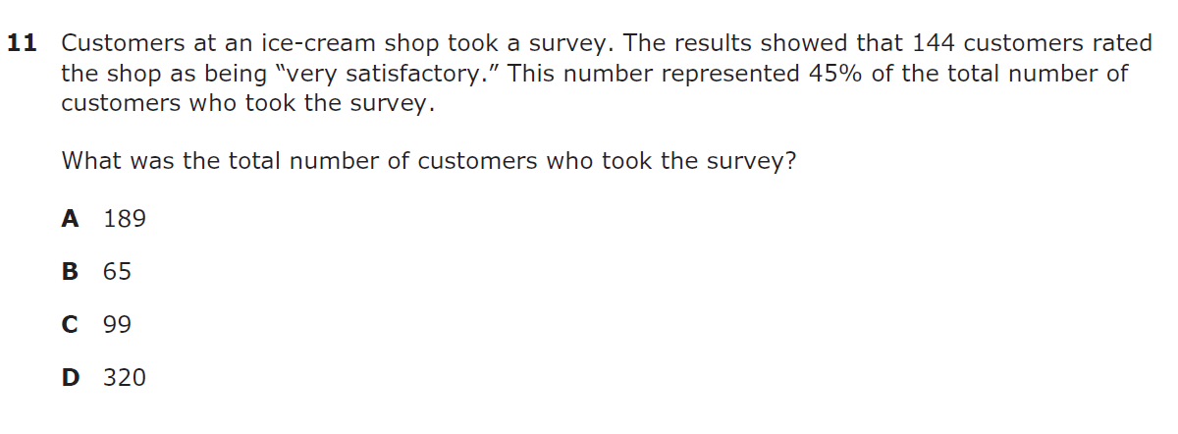

6.5B – 2 (R) fifteen X
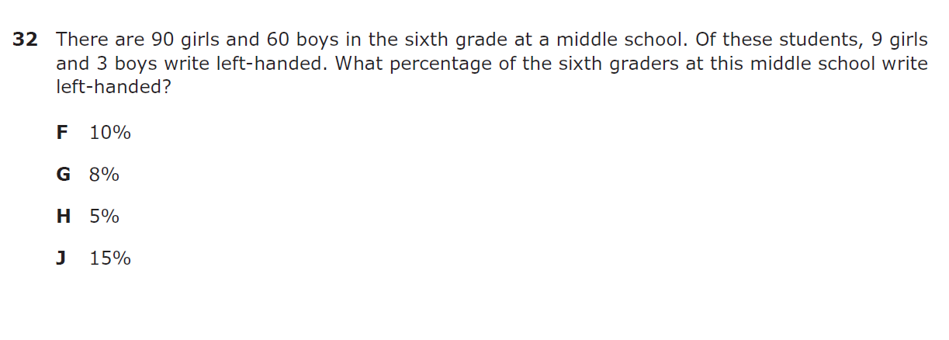

6.5B – 2 (R) sixteen Y

6.5B – 2 (R) sixteen W
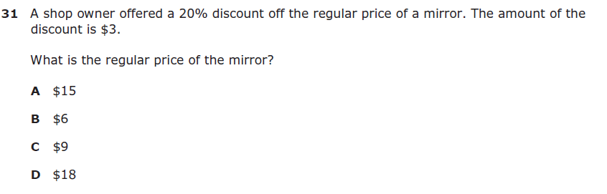

6.6C – 2 (R) twenty six X
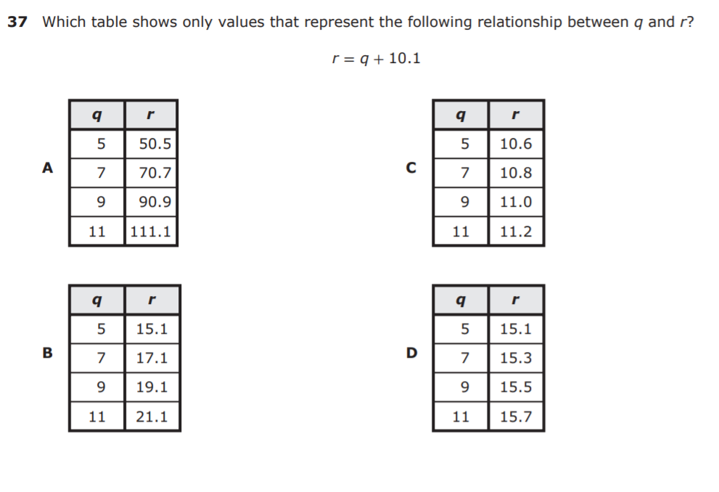
6.6C – 2 (R) twenty seven Y
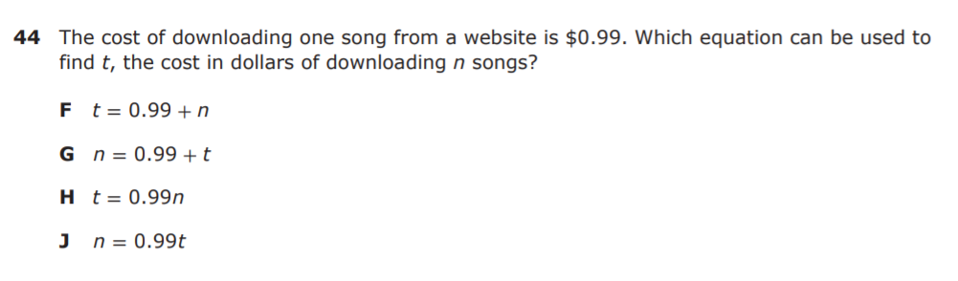

6.6C – 2 (R) sixteen W
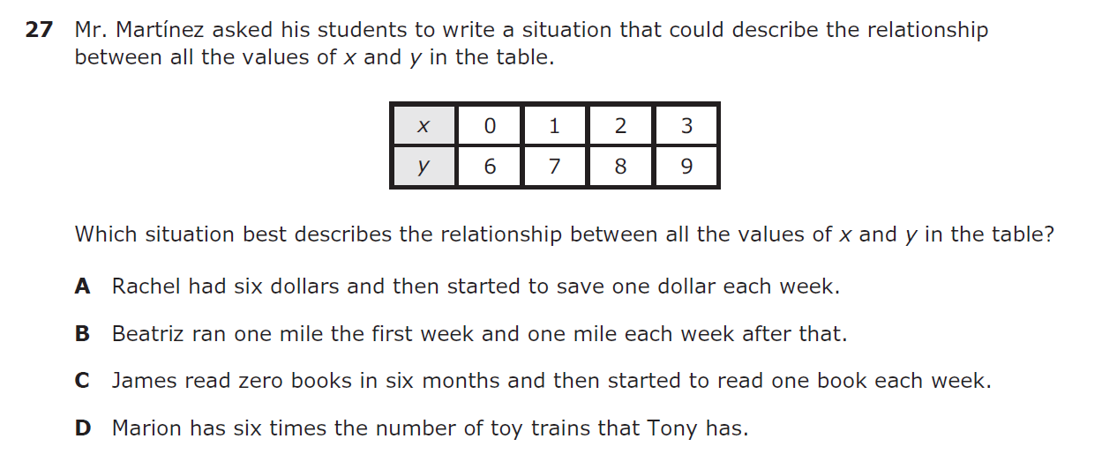

6.6C – 2 (R) seventeen Z 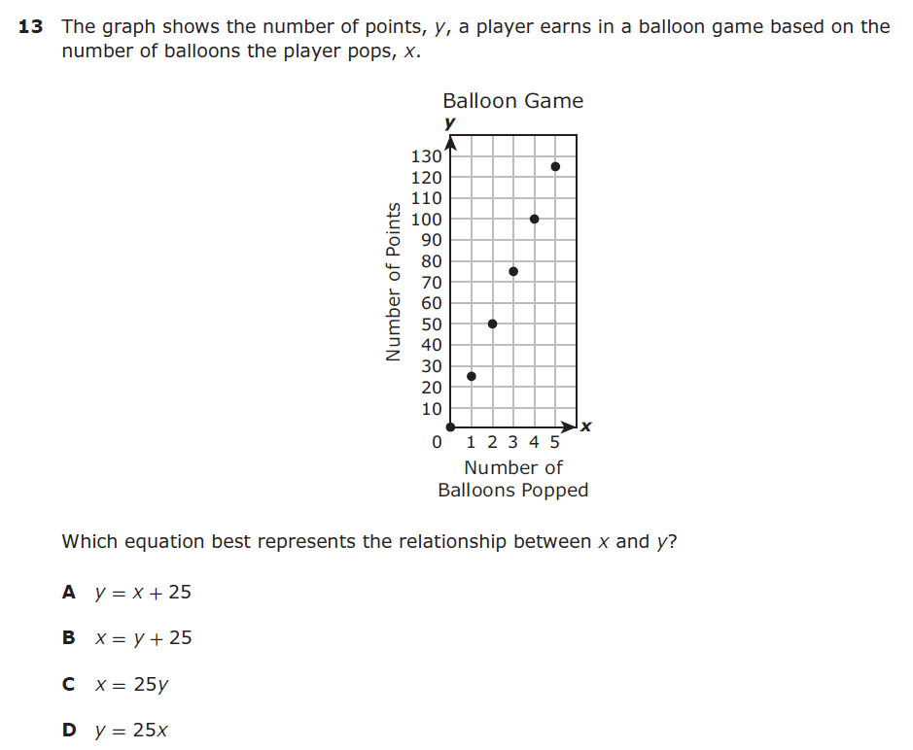
6.6C – 2 (R) seven W
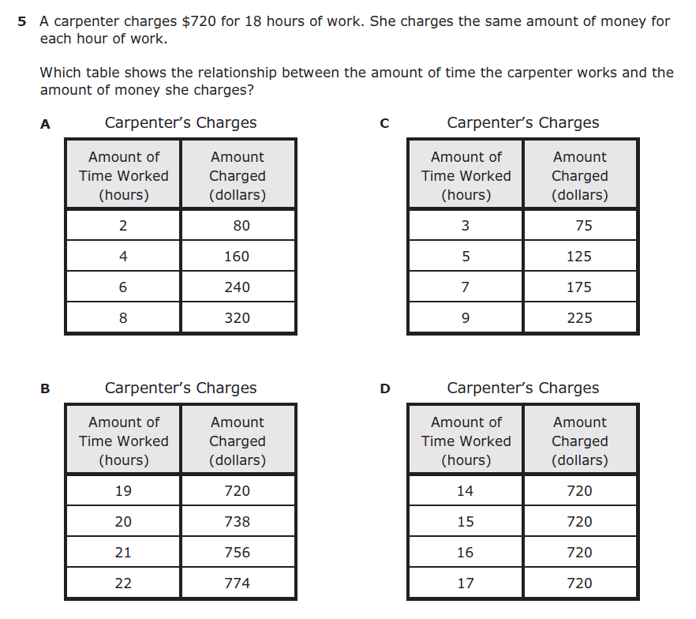
6.6C – 2 (R) eight W
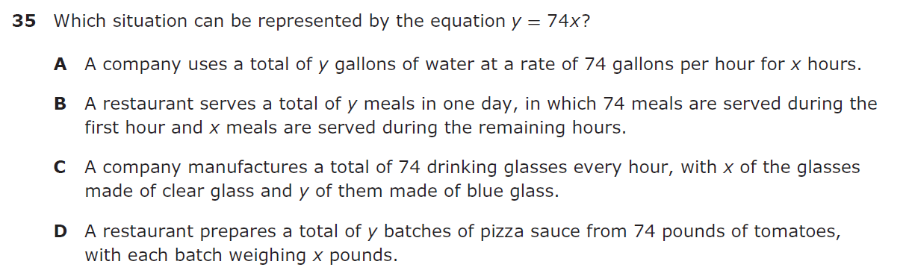

6.7A – 1 (R) twenty eight X
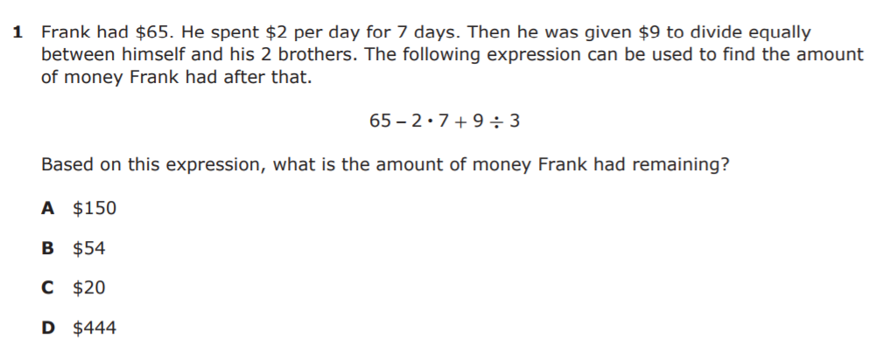

6.7A – 1 (R) twenty nine Z
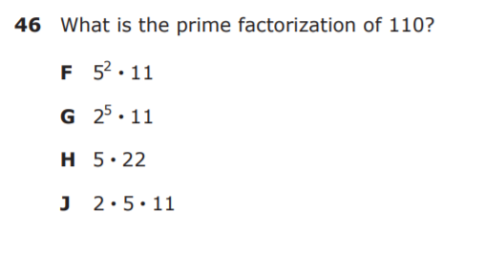

6.7A – 1 (R) eighteen
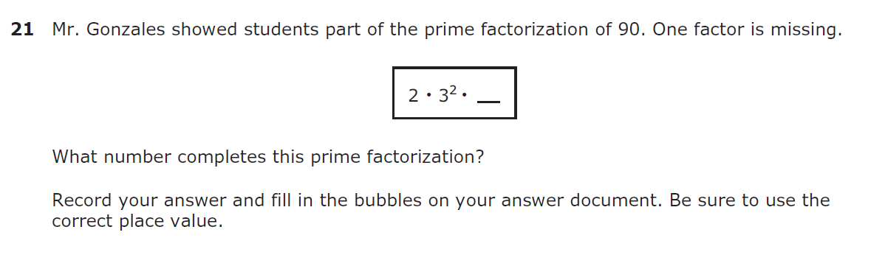
6.7A – 1 (R) nineteen Z
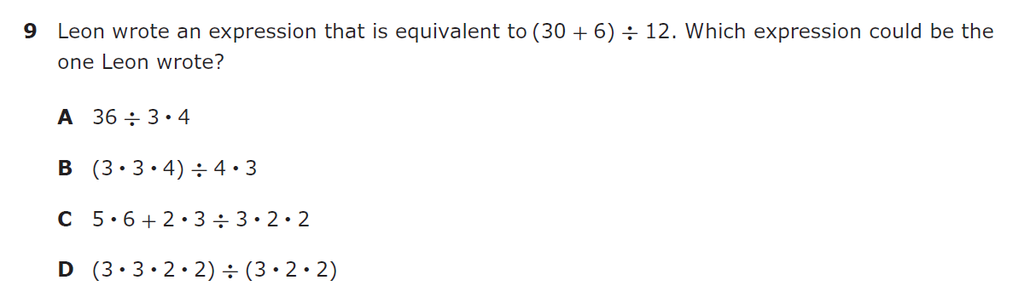

6.7A – 1 (R) twenty nine W
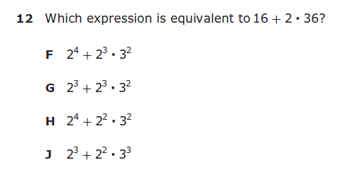

6.7A – 1 (R) twenty nine Y
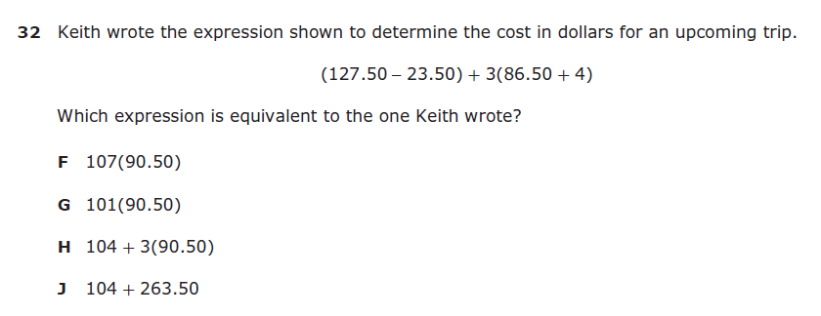

6.7D – 1 (R) thirty Y
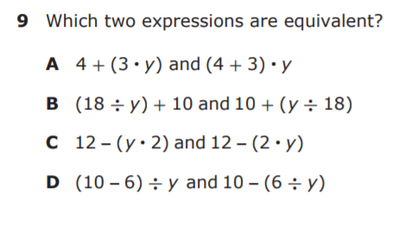

6.7D – 1 (R) thirty one W
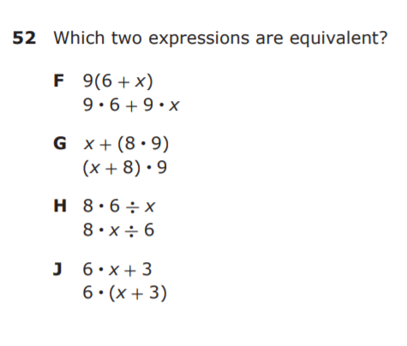

6.7D – 1 (R) twenty X
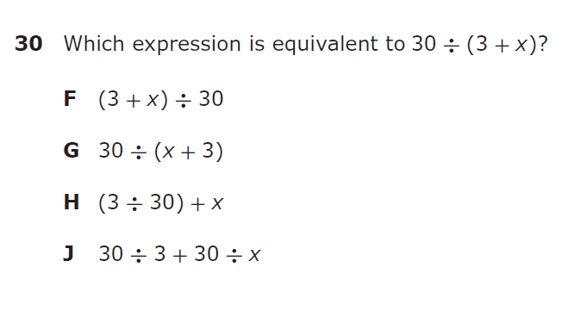

6.7D – 1 (R) twenty one Y
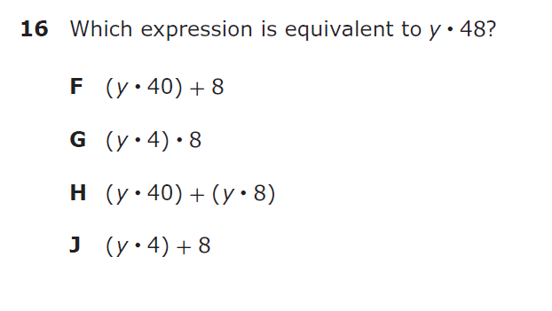

6.7D – 1 (R) seven Z
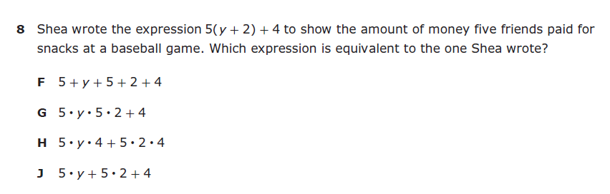

6.8A – 3 (R) seventeen W
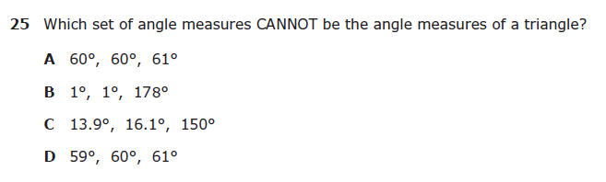

6.8D – 3 (R) thirty four Z
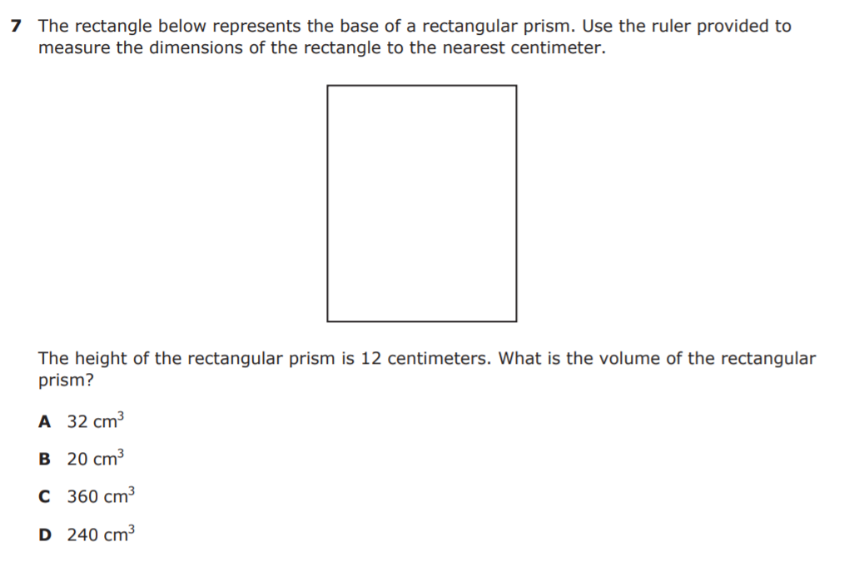

6.8D – 3 (R) thirty five W
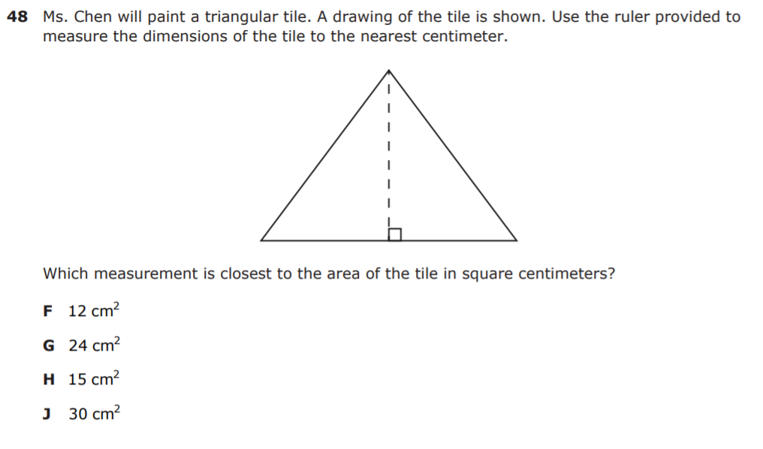
6.8D – 3 (R) twenty four X
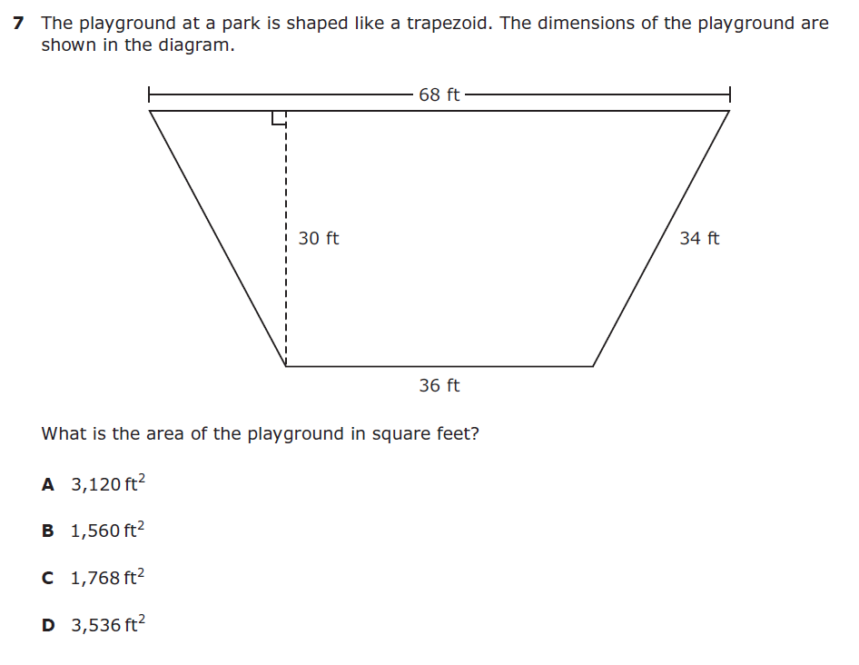
6.8D – 3 (R) twenty five X
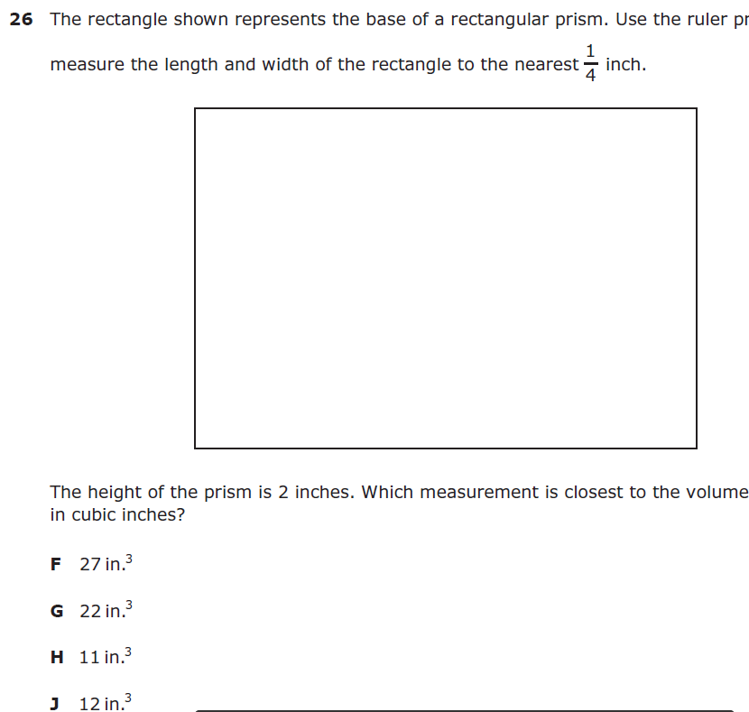
6.8D – 3 (R) twenty six W
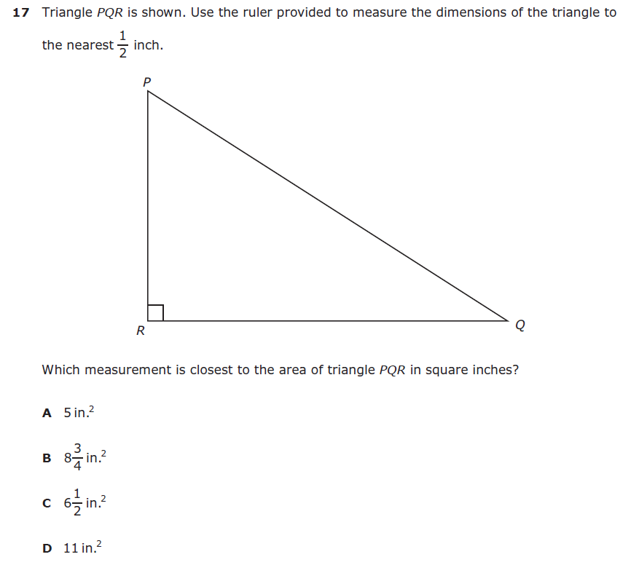
6.8D – 3 (R) twenty seven Y
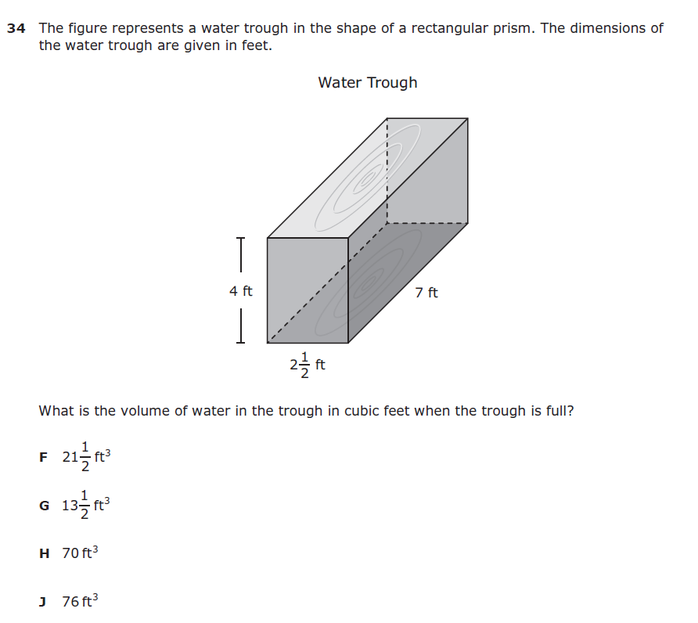
6.10A – 2 (R) thirty eight X
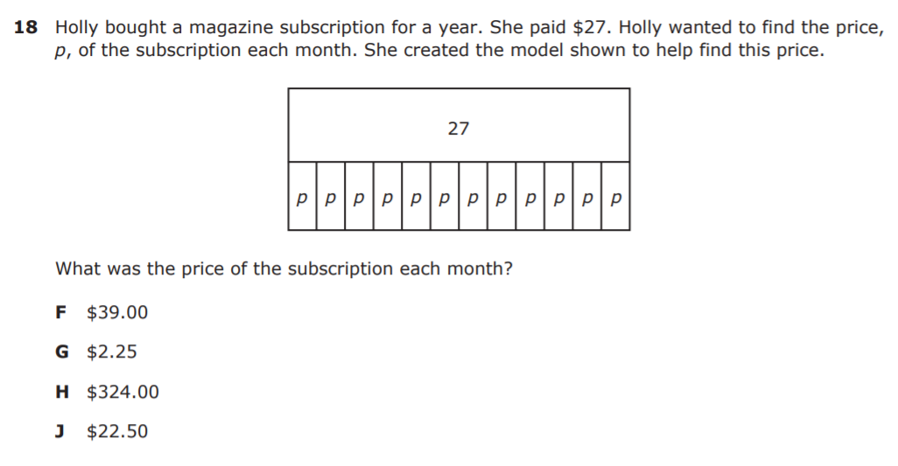

6.10A – 2 (R) thirty nine Z
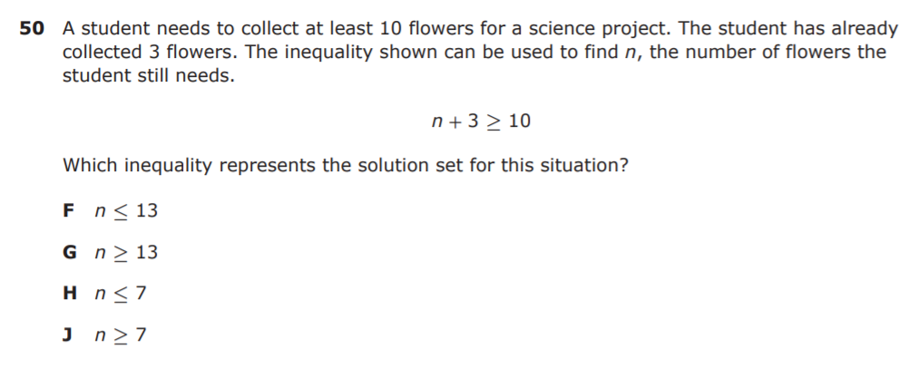

6.10A – 2 (R) twenty eight X
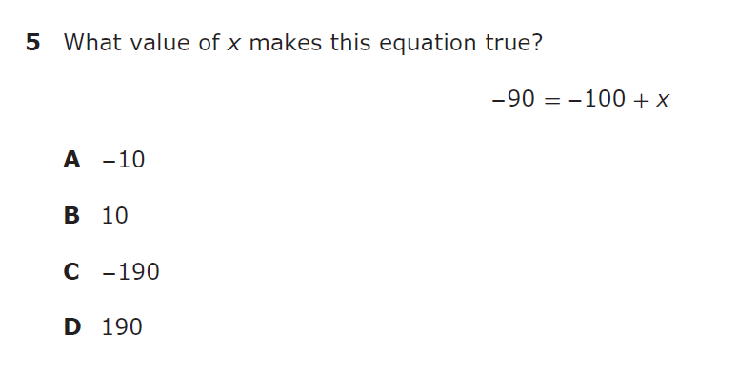

6.10A – 2 (R) twenty nine Y
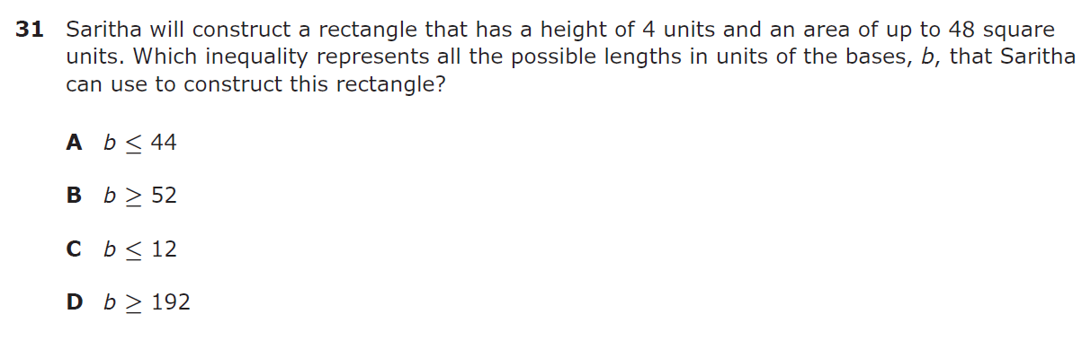

6.10A – 2 (R) thirty Y
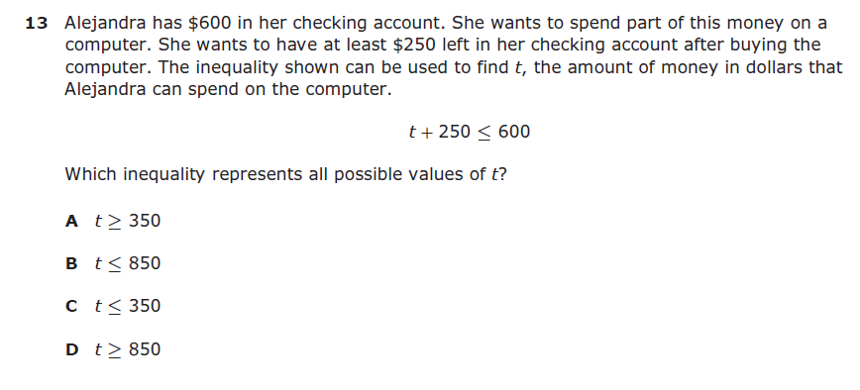

6.10A – 2 (R) thirty one Y
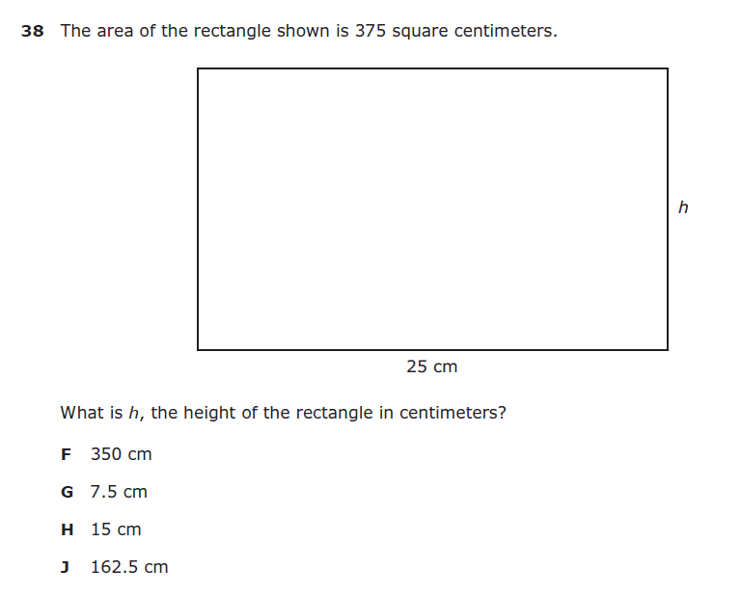
6.11A – 3 (R) forty one X
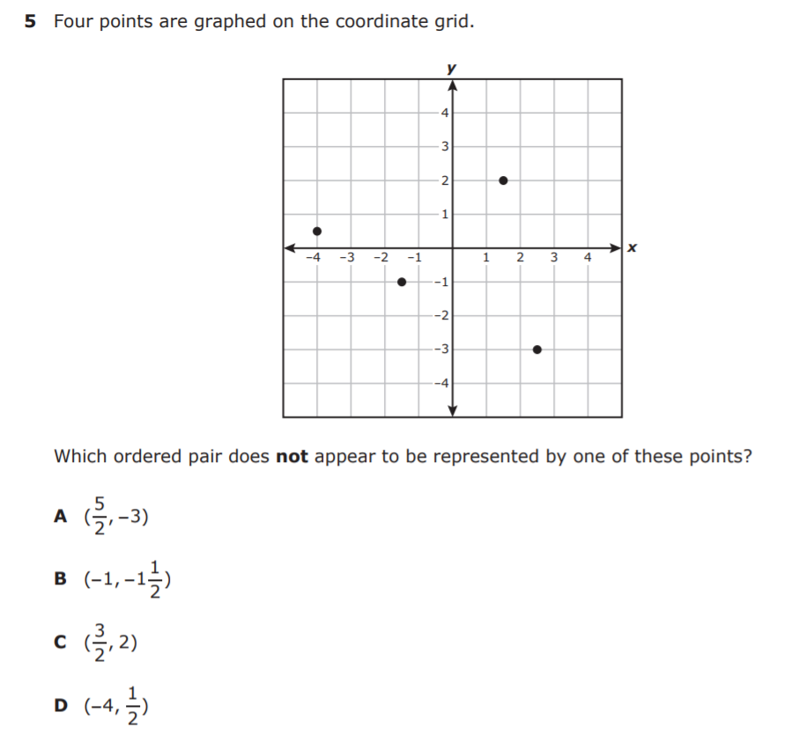
6.11A – 3 (R) forty two Y
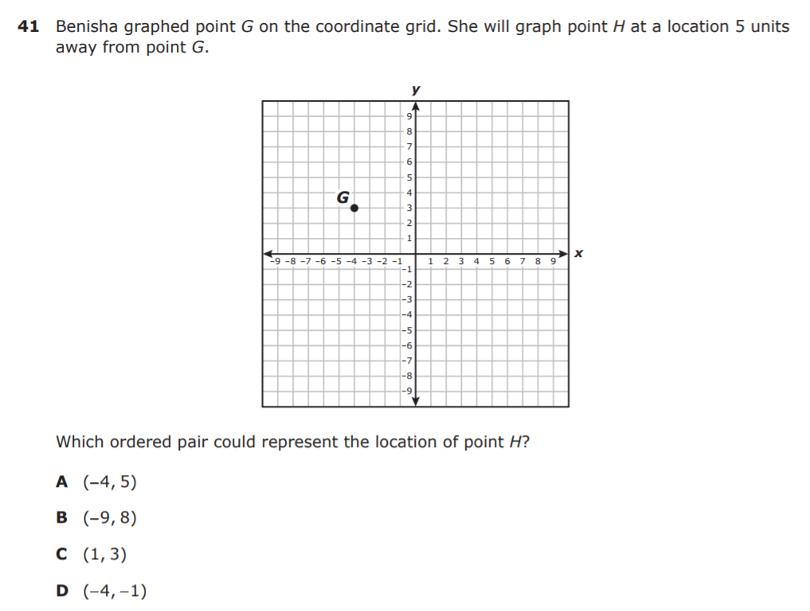
6.11A – 3 (R) thirty one X
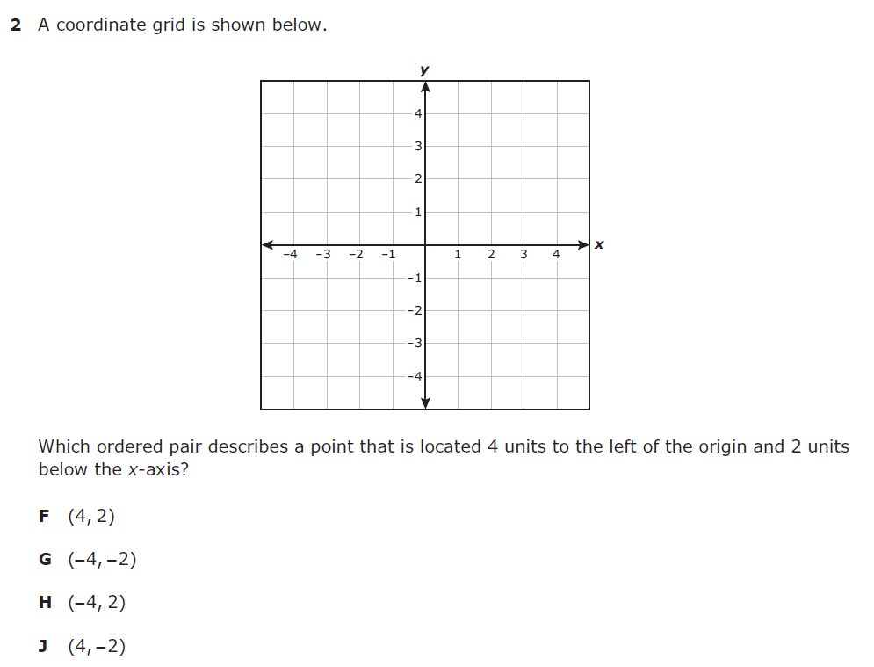
6.11A – 3 (R) thirty two -6
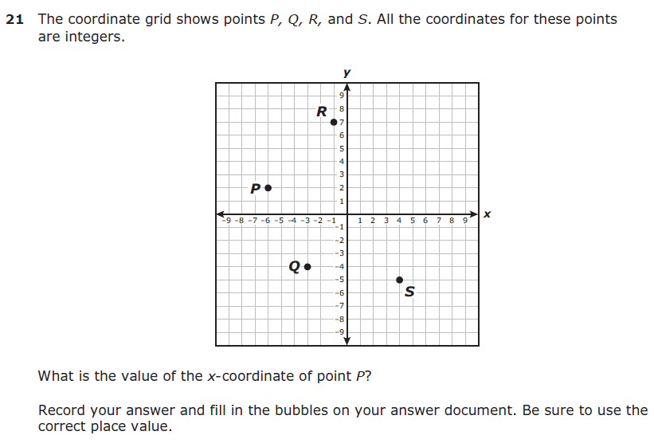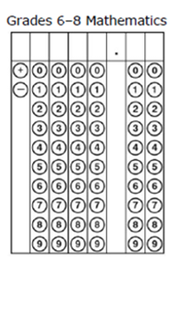

6.12C – 4 (R) forty four Z
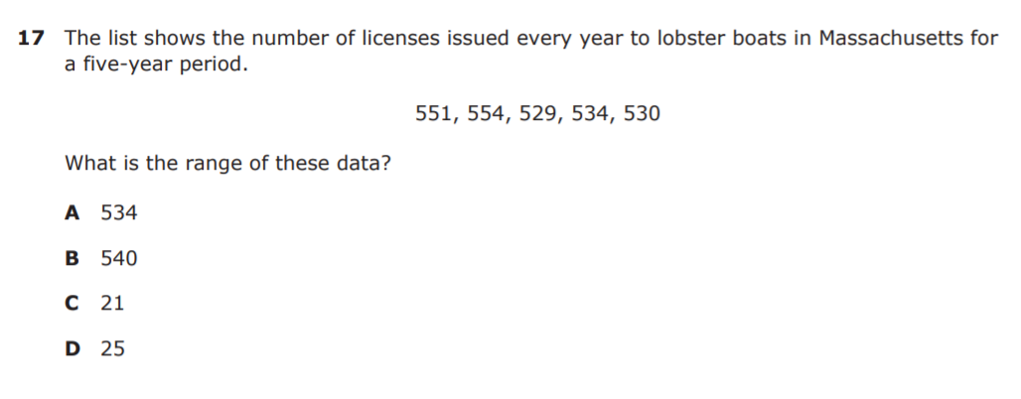

6.12C – 4 (R) forty five X
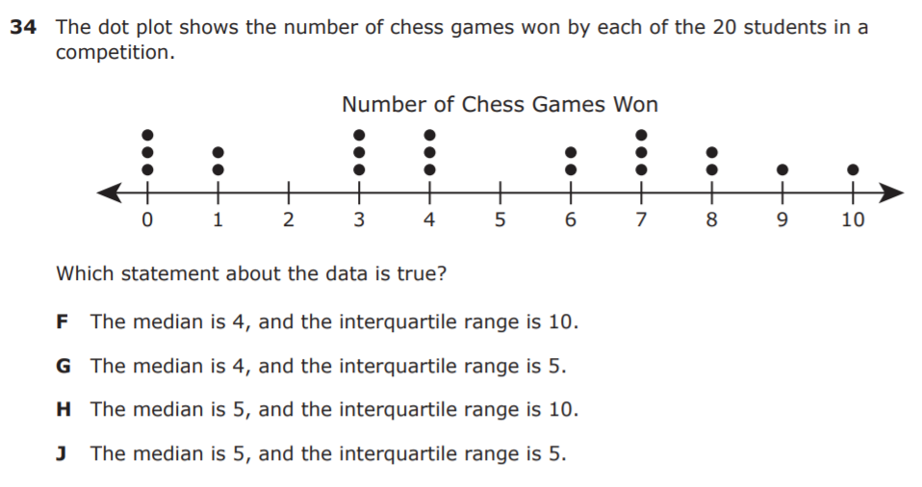

6.12C – 4 (R) Ans: – 444 thirty three
6.12C – 4 (R) thirty three X
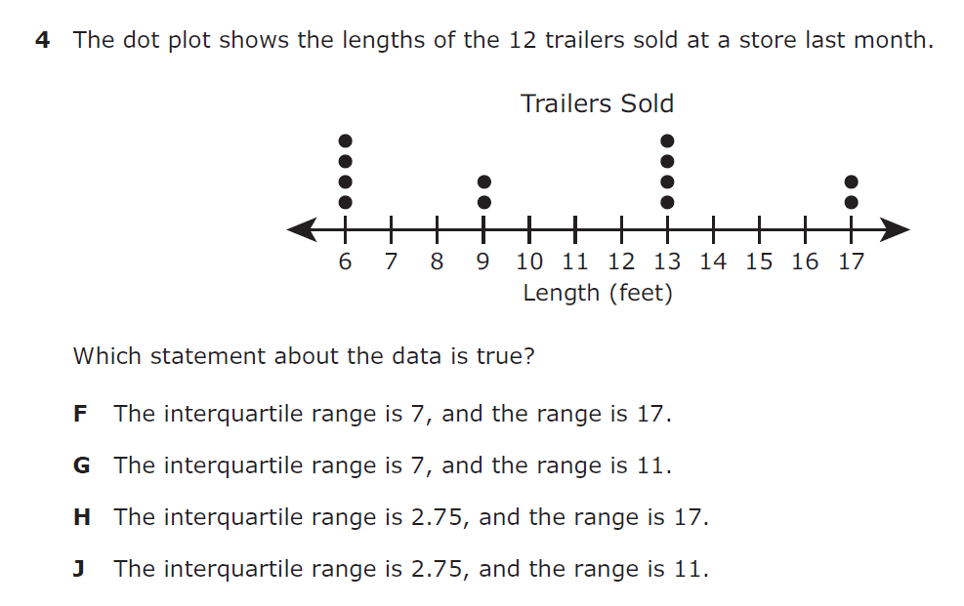
6.12C – 4 (R) thirty four 18
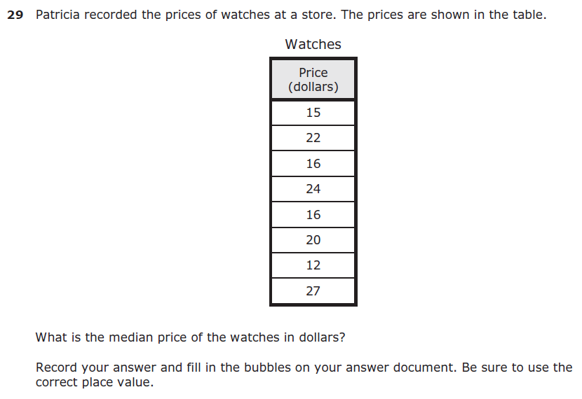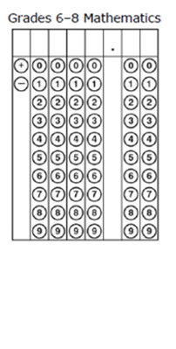

6.12D – 4 (R) forty six Y
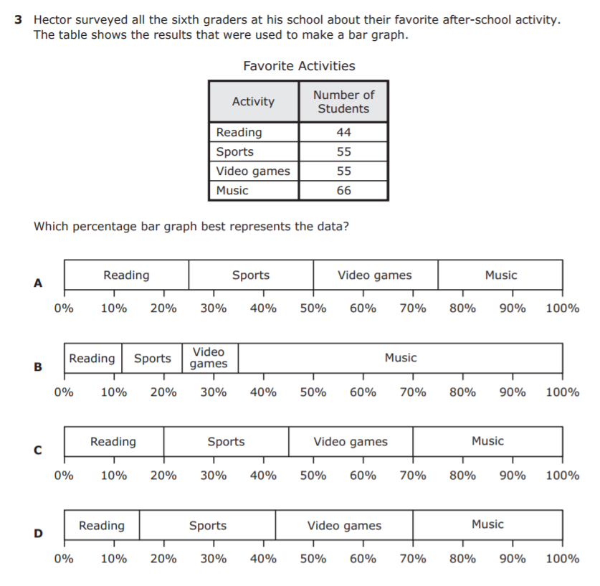
6.12D – 4 (R) forty seven Z
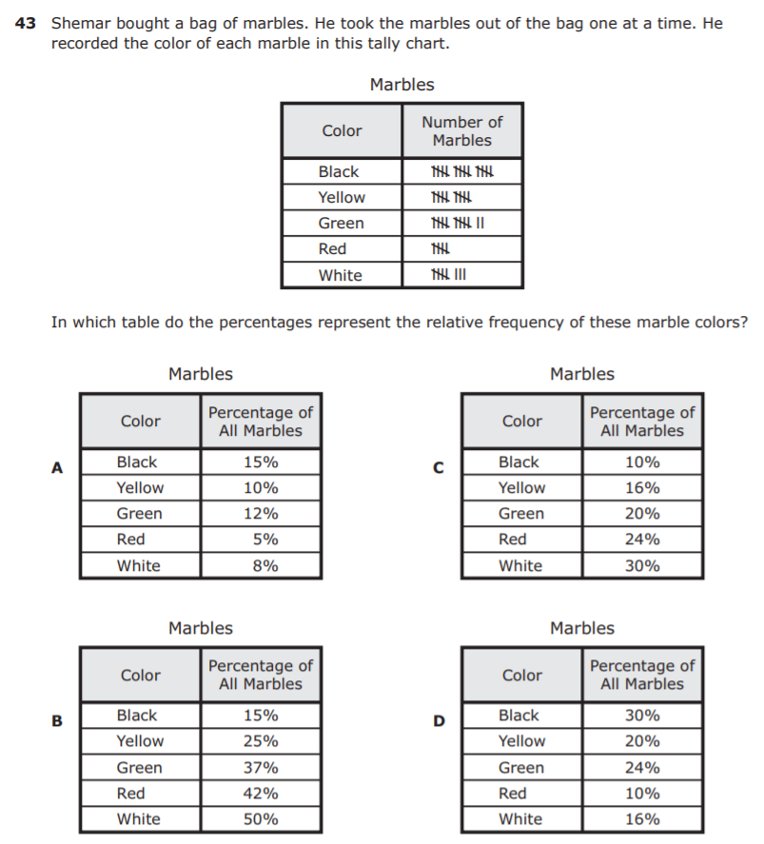
6.12D – 4 (R) thirty four Y
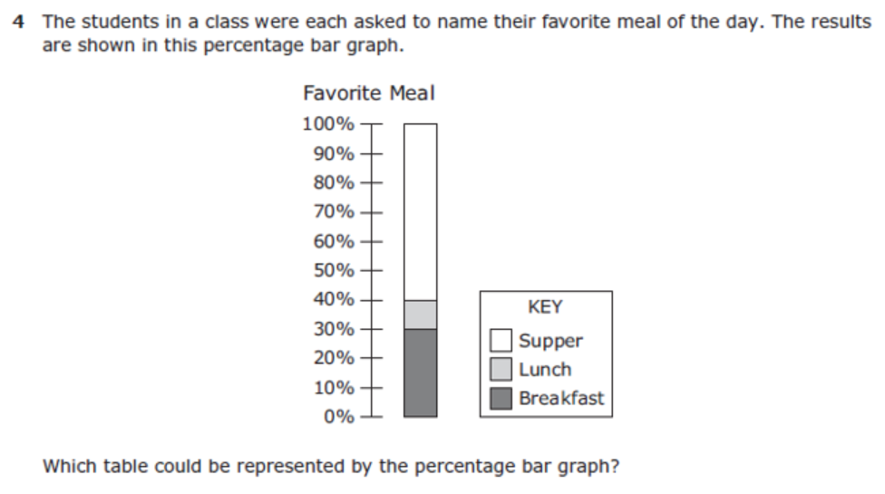
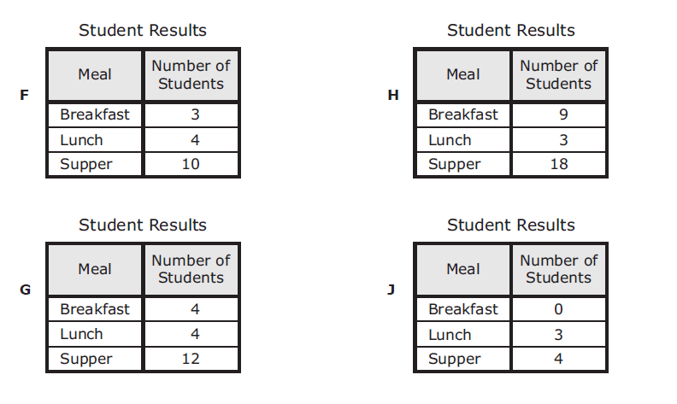

6.12D – 4 (R) thirty five Z
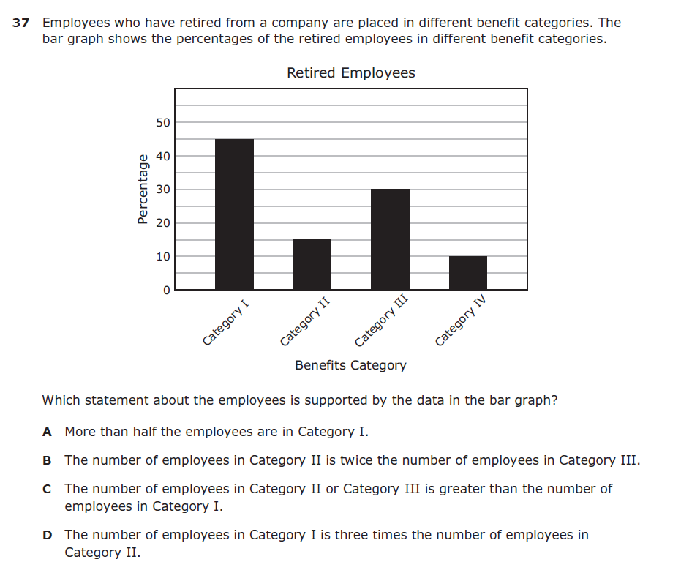
6.13A – 4 (R) forty eight W
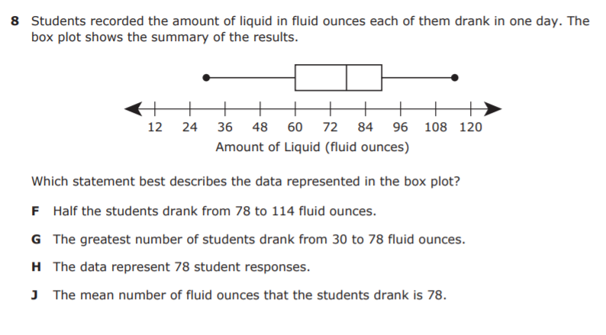

6.13A – 4 (R) forty nine Y
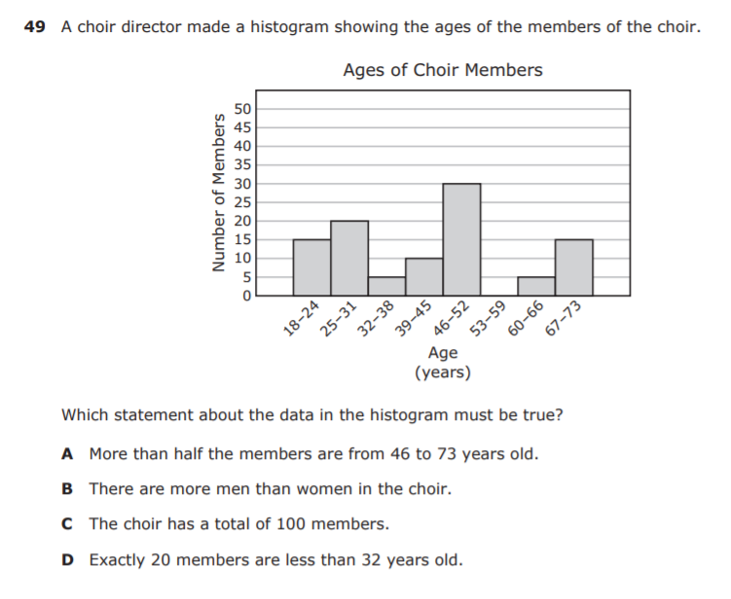

6.13A – 4 (R) thirty five W
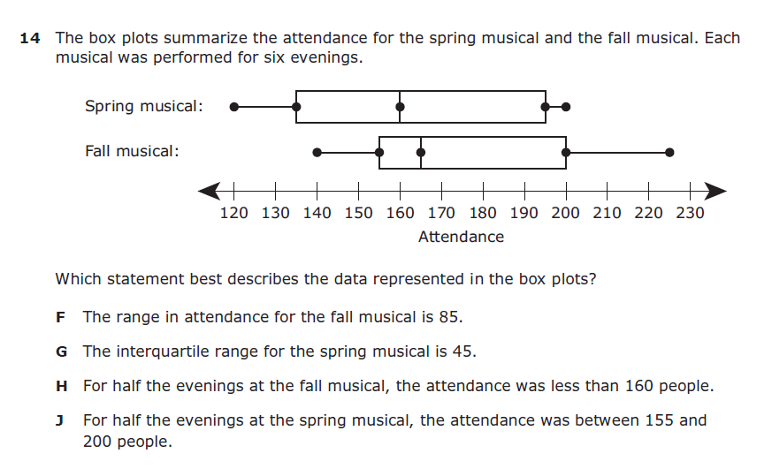
6.13A – 4 (R) thirty six Z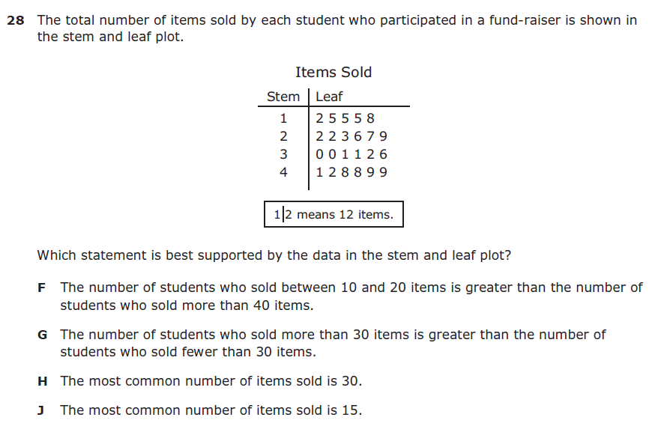
6.13A – 4 (R) thirty seven Y
